Go to: http://www.crimemapping.com
- Select PA.
  - Select a medium sized city. (one with more than 30 crimes visible) I suggest zooming out and moving around the map to find a concentrated area of crime.
Please answer the following questions:
- Create a crime map for any area you are interested in. What are your selected Location, Incident Types and Time Period?
- What are the geographical patterns of the crimes in the crime map?
- What types of incidents are most frequent in the crime map? What are the geographical patterns of the incidents (Refer to the street names)?
- If you were the mayor of the city, how could you use this system to improve the safety of visitors and residents and why?
Use the buttons on top of the website to gather information i.e. Crime Trends, Detailed Reports etc.

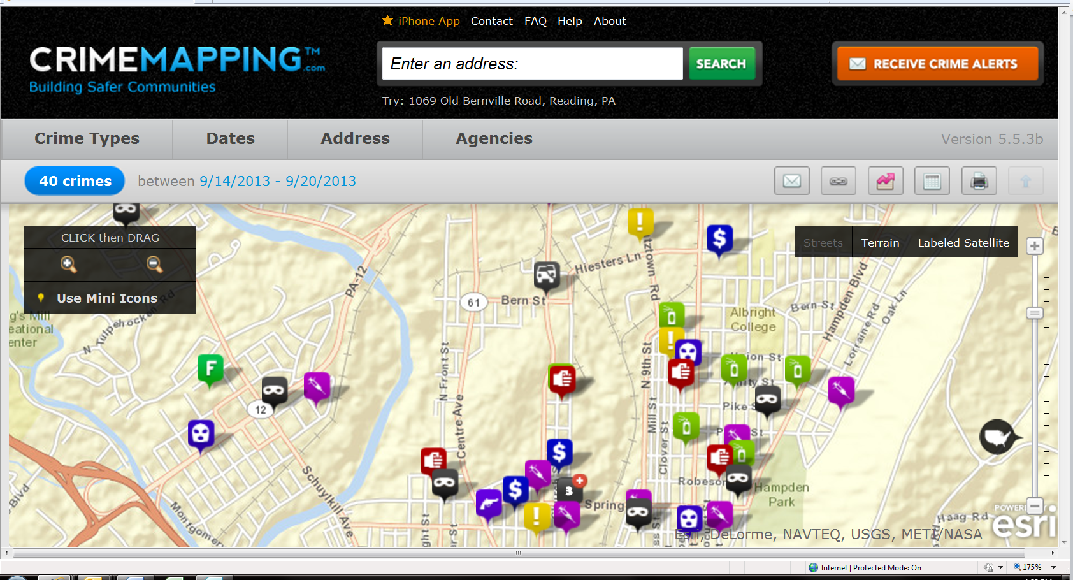
Add a link to your finished product so that I can compare what you found to the data.
Ex: http://www.crimemapping.com/map.aspx?ll=-8452239.623300856,4918086.4463148&z=14&mc=world-street&cc=AR,AS,BU,DP,DR,DU,FR,HO,VT,RO,SX,TH,VA,VB,WE&db=9/14/2013&de=9/20/2013

